Steps to Submit Abstract in the conference through EDAS platform

- Go to https://edas.info/
- Click on “create a new account” and create your own account:
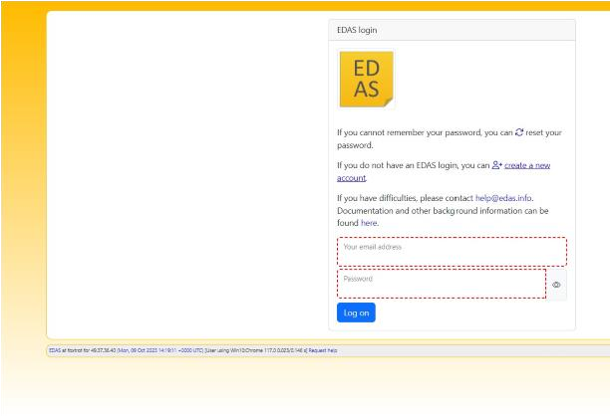

- Fill in the following details while creating it:
  - Name
  - Phone Number
  - Email Id
  - Status (Student)
  - Organisation (for IEM students, it will be Institute of Engineering and Management, Kolkata)
  - URL (give your own institute’s website link. For IEM students, it will be: https://iem.edu.in)
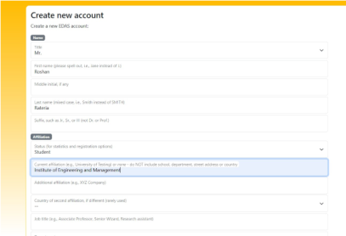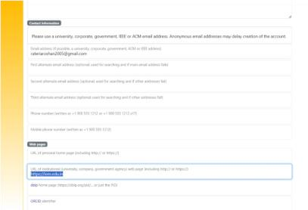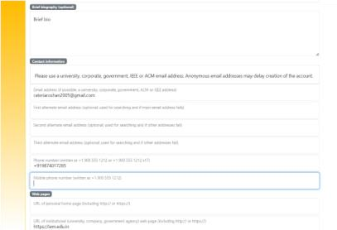
- Give consent to Terms and Condition
- Click Add this person
- Now go to https://edas.info/newPaper.php?c=31466
- Add the details as asked in the link and submit Your abstract.

